Cristian Rodriguez

CMPM 147

W1561133

Assignment 4: Evolving Cars

Link to repository: <https://github.com/crod95/UCSC-Generative-Design/tree/master/asg4v2>

Generation 1:

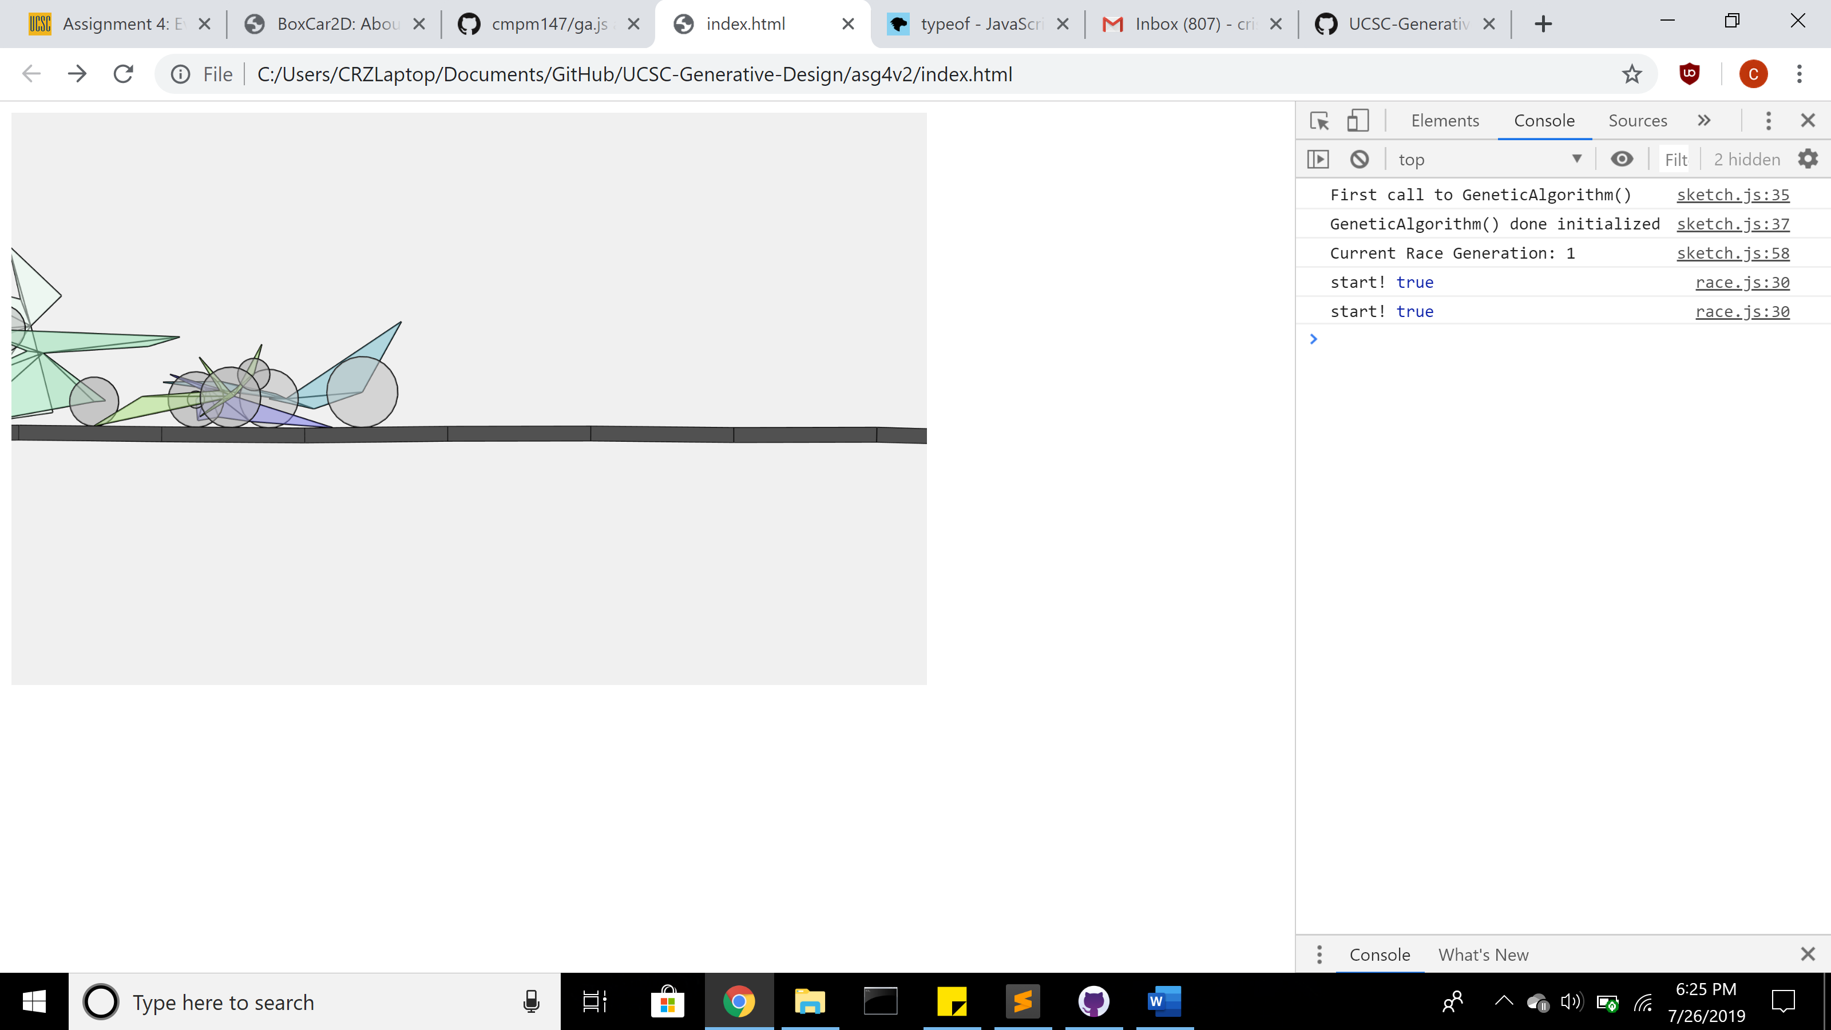

Generation 4:

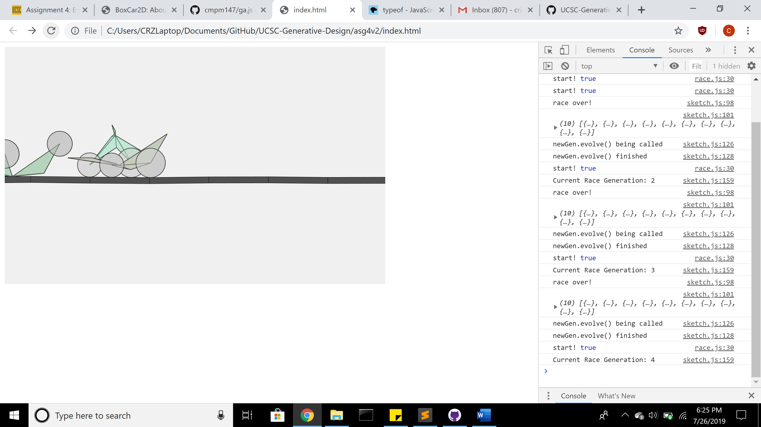

Generation 6:

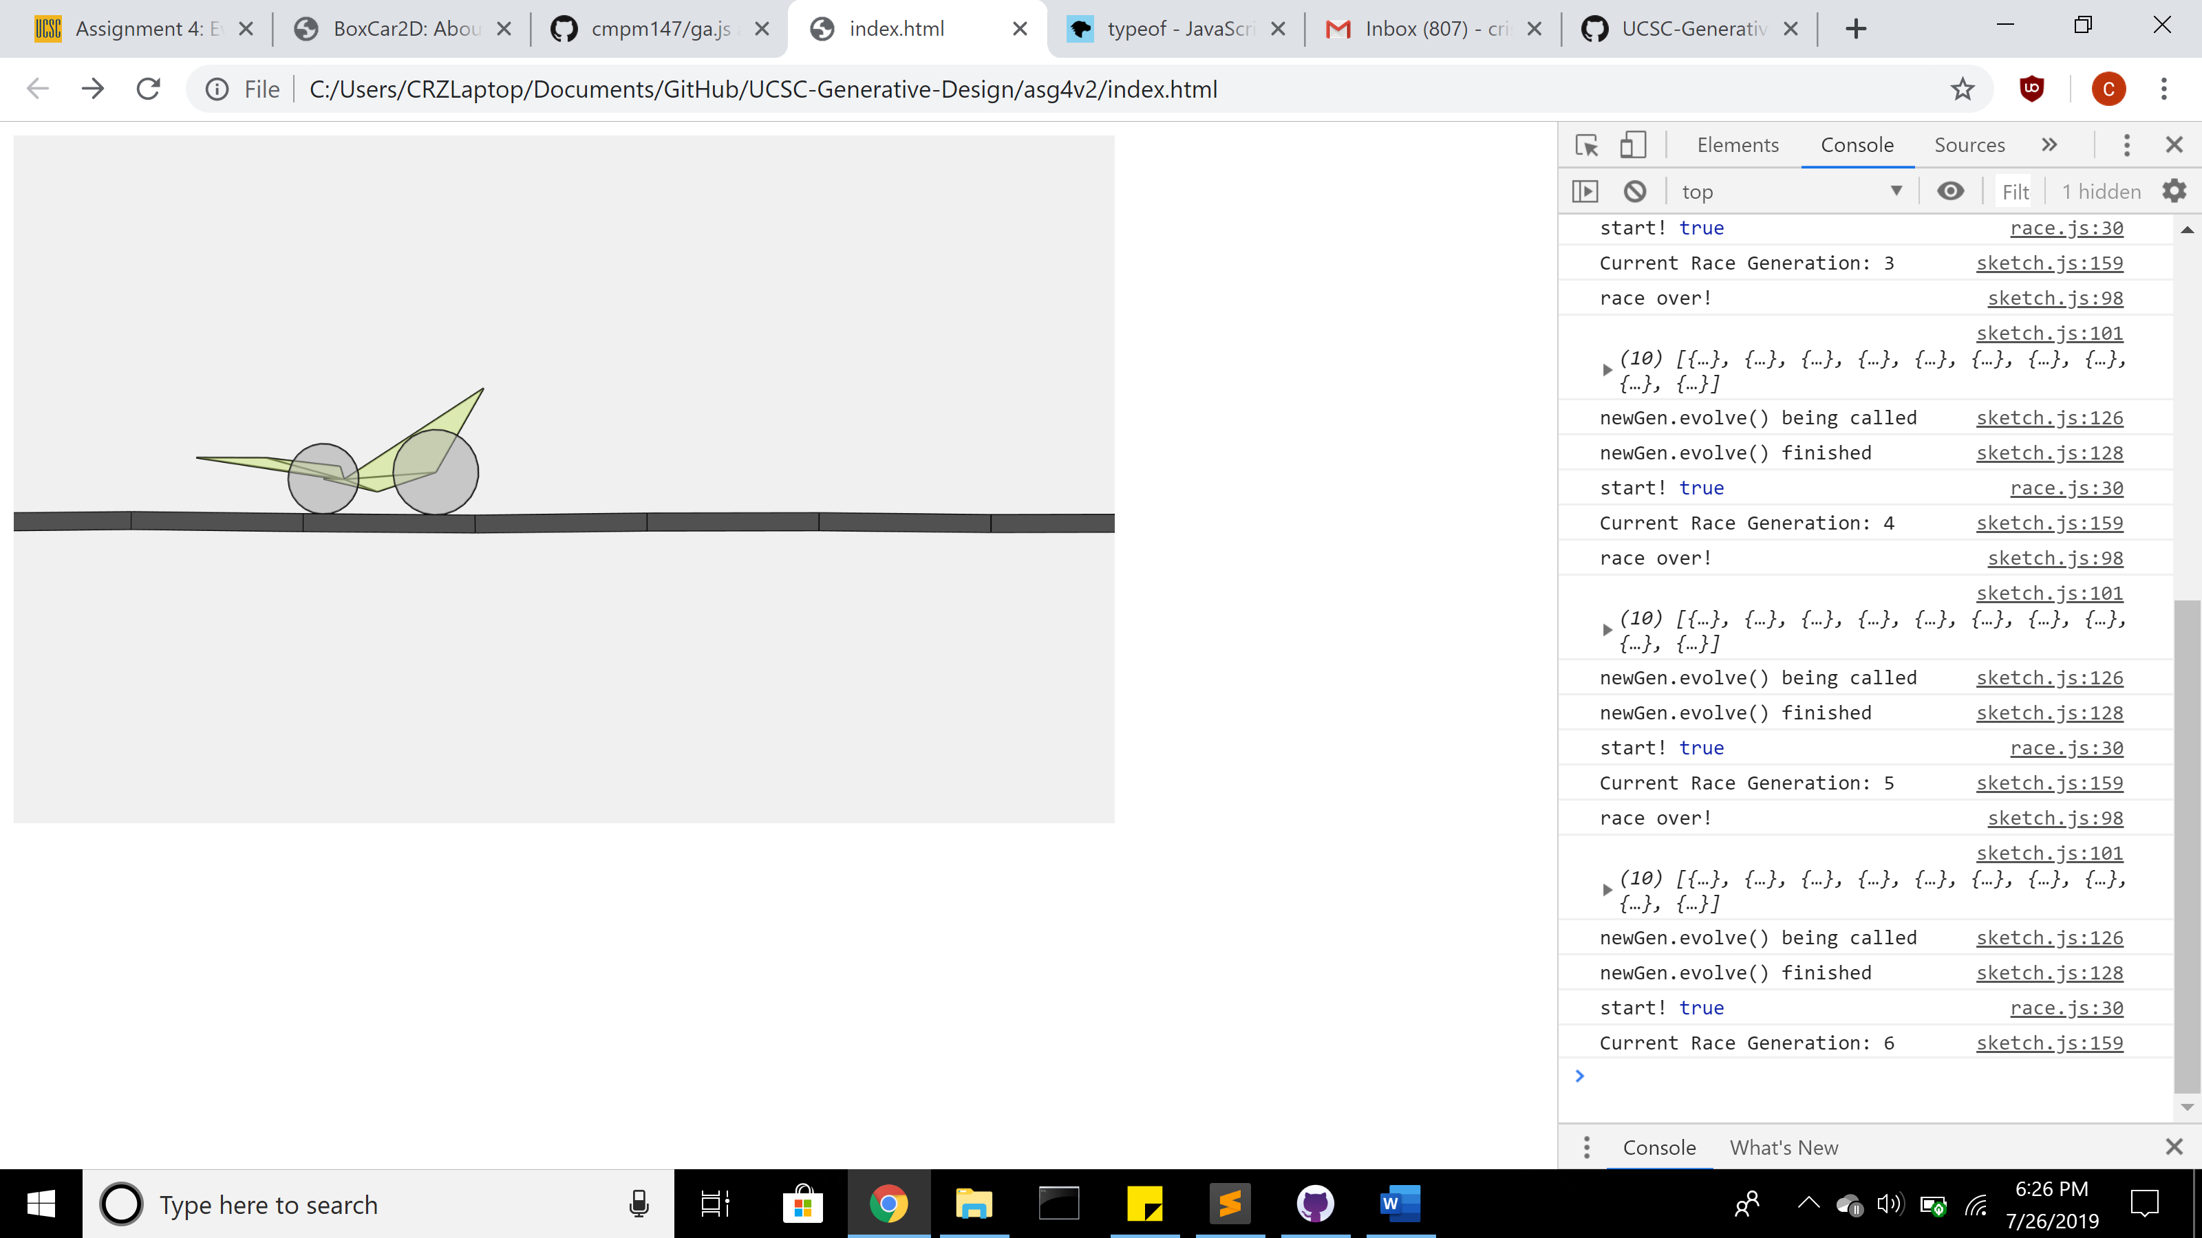

This program starts out with a random generation of cars that are all created with 8 randomized vertices spanning out from a center point with 2 randomized wheels on one of the 8 vertices. Each car drives as far as they can along the route and their progress is determined by how far they are able to drive. Once all cars stop, the genetic algorithm runs to evolve the current generations of cars to the next based on how well the previous generation of cars ran. The better a car ran in the race, the better chance it has at reproducing offspring. There is also a chance that the offspring may have a mutation to one of its genes, such as the location of one of its vertices or the size of one of its wheels. This continues as the program goes on as each generation goes through a various changes.